

**Submitted By:**

**Name: Ayman Hasib**

**Registration: 18201065**

**Sec: B1  
Course Code: CSE 320**

**Course Name: Computer Networking Lab**

**Date: 09/09/2021**

**Submitted to:**

**Dr A S M Touhidul Hasan**

**Designation: Assistant Professor**

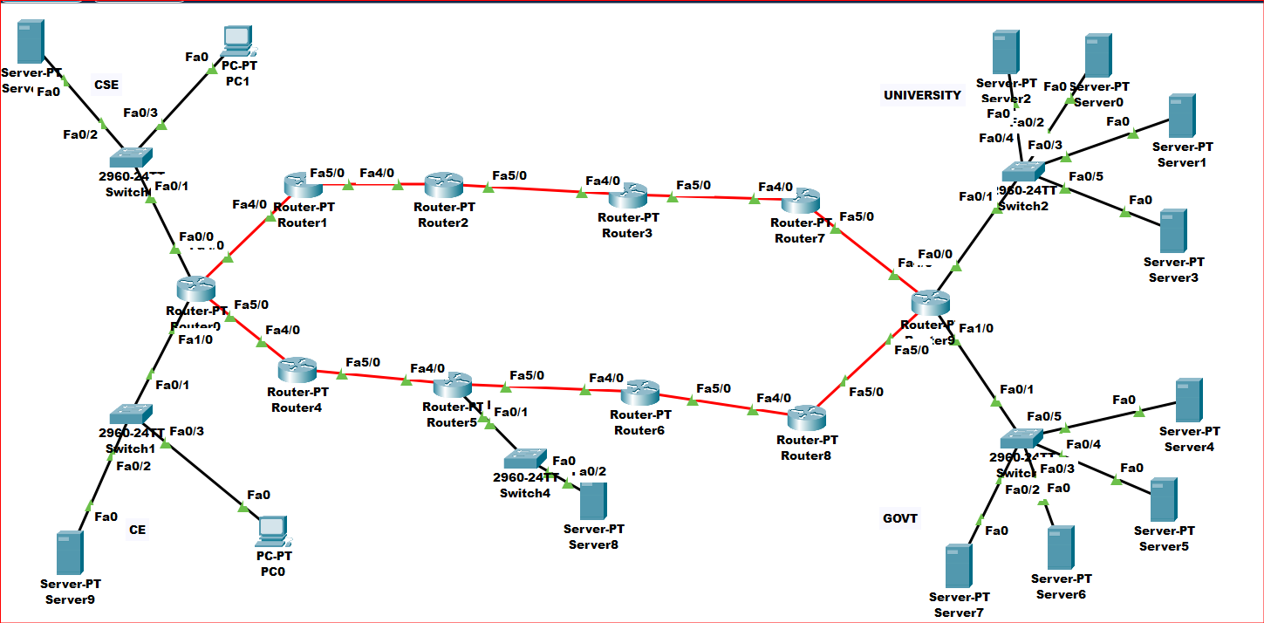

Here Cse, Ce and all the network connected with the routers.

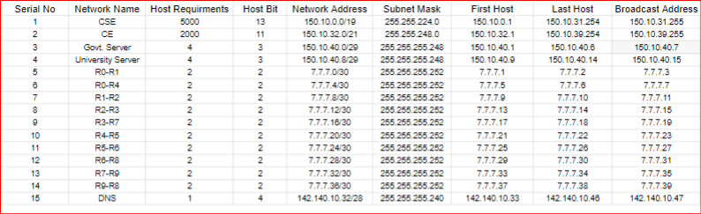

VLSM Calculation.

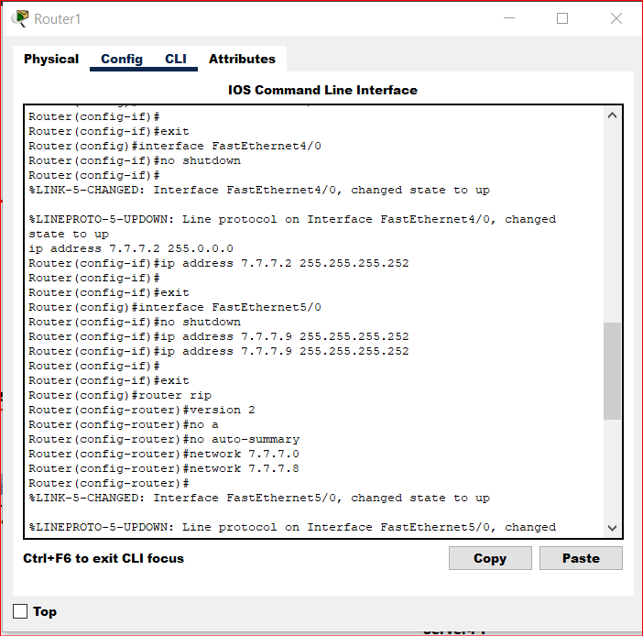

Adding corresponding networks to the routers.

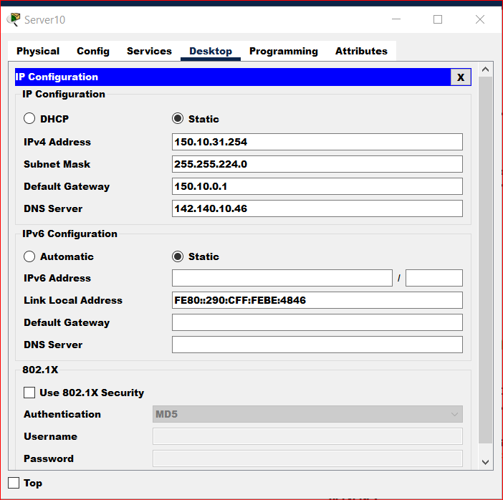

Configuring servers by giving the address

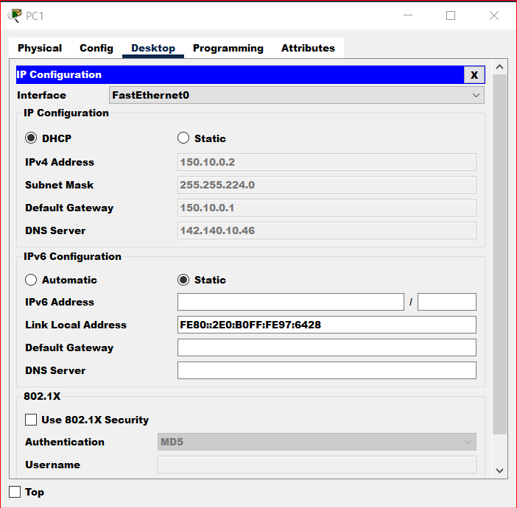

Configuring the PC by DHCP request.

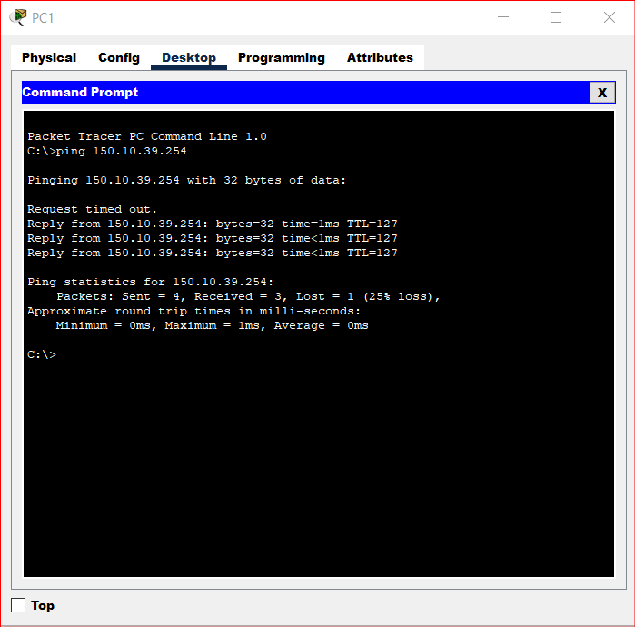

Ping to a server from PC 1.